A000-Afr-Gabon-Vouvi puppet-Early 20th c

Gabon, Vouvi Puppet, Size : 25.590 inches, 6.720 pounds, wood, leather, polychrome.

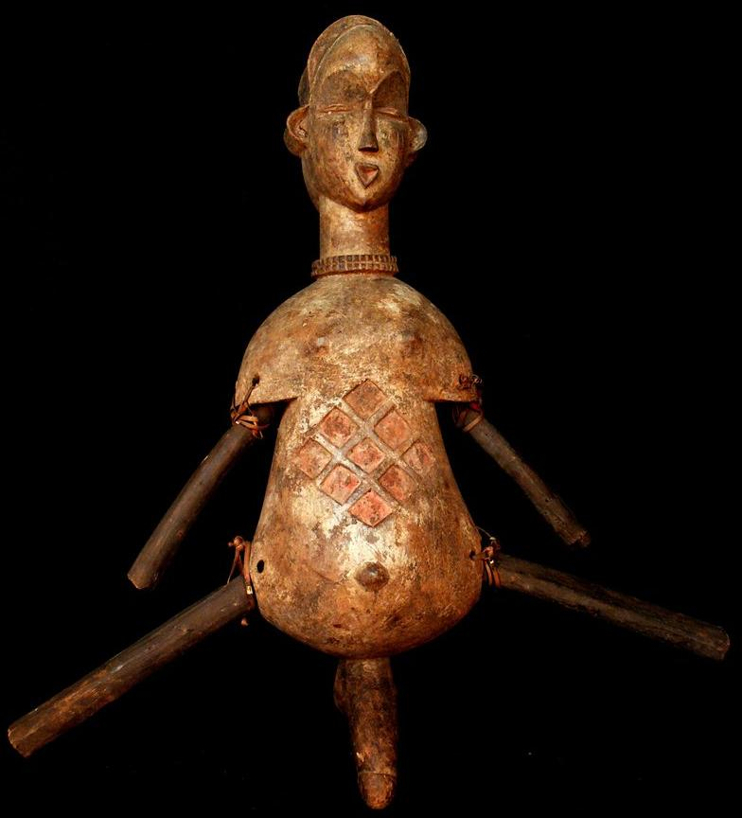

The **Mitsogo** are a Bantu people of Central Africa established the center of Gabon in the province of [Ngounié](http://translate.googleusercontent.com/translate_c?depth=1&ei=1pMeUePMF6rr0gGcgoHoBA&hl=en&prev=/search%3Fq%3D%2522MITSOGHO%2522%26hl%3Den%26lr%3D%26tbo%3Dd%26as_qdr%3Dall&rurl=translate.google.ca&sl=fr&u=http://fr.wikipedia.org/wiki/Ngouni%25C3%25A9&usg=ALkJrhg4JNmqzqYht1fL1LpD3QKBsmCBHQ) . Traditionally farmers (slash and burn) and matrilineal , the Mitsogo are known for their religious rituals, initiation sophisticated, including the [*Bwiti*](http://translate.googleusercontent.com/translate_c?depth=1&ei=1pMeUePMF6rr0gGcgoHoBA&hl=en&prev=/search%3Fq%3D%2522MITSOGHO%2522%26hl%3Den%26lr%3D%26tbo%3Dd%26as_qdr%3Dall&rurl=translate.google.ca&sl=fr&u=http://fr.wikipedia.org/wiki/Bwiti&usg=ALkJrhhCdZe8o5Wi-7vAh23mlFXlYv7wvg) (world knowledge, know-thyself, so the obvious humanity ) or *Mwiri* for males (known for training warrior men), and *Nyembe* (for women, girls learn the skills and occupations of women in society and even its place.

*Bwété,* according to the appellation of origin is a tradition that includes part initiatory religious part of the learning actants of the world (forms, theories, concepts) for economic development and stability control of the company by the mask in a myriad of prohibitions.

Mitsogo masks are covered with white pigments. They are characterized by an open mouth, a small triangular nose and eyes elongated surmounted by eyebrows shaped "M" Jean-Baptiste Bacquart, *The Tribal Art of Black Africa,* Thames & Hudson, 2010, (ed . original English 1998), p. 116-117

### References

* Otto and Roger Gollnhofer Sillans, "Research on the mysticism of Mitsogo: mountain people of central Gabon (equatorial Africa)," *Reincarnation and mystical life* in *Black Africa,* Paris, 1965
* Otto Gollnhofer, *rites of passage initiation of society in Bwete Mitsogho: the chewing of iboga,* Université René Descartes, Paris V, 1974
* Otto Gollnhoffer, "Phenomenological aspects of initiation and destruction of the state of consciousness usually temporary in Mitsogho of Gabon," in [*African Psychopathology*](http://translate.googleusercontent.com/translate_c?depth=1&ei=1pMeUePMF6rr0gGcgoHoBA&hl=en&prev=/search%3Fq%3D%2522MITSOGHO%2522%26hl%3Den%26lr%3D%26tbo%3Dd%26as_qdr%3Dall&rurl=translate.google.ca&sl=fr&u=http://fr.wikipedia.org/wiki/Psychopathologie_Africaine&usg=ALkJrhj3dNKdgzi9BGTXgh2VwOQBasVpJw) , XII, 1, 1976, p. 45-75
* Otto and Roger Gollnhofer Sillans *memory of a people Mitsogho ethno-history, ethnicity of central Gabon,* Presence Africaine, Paris, Dakar, 1997, 244 p. ( [ISBN 2708706403](http://translate.googleusercontent.com/translate_c?depth=1&ei=1pMeUePMF6rr0gGcgoHoBA&hl=en&prev=/search%3Fq%3D%2522MITSOGHO%2522%26hl%3Den%26lr%3D%26tbo%3Dd%26as_qdr%3Dall&rurl=translate.google.ca&sl=fr&u=http://fr.wikipedia.org/wiki/Sp%25C3%25A9cial:Ouvrages_de_r%25C3%25A9f%25C3%25A9rence/2708706403&usg=ALkJrhi6WkCR0eJWVC9kwR82bZFP_JDeEQ) )
* [Raponda-André Walker](http://translate.googleusercontent.com/translate_c?depth=1&ei=1pMeUePMF6rr0gGcgoHoBA&hl=en&prev=/search%3Fq%3D%2522MITSOGHO%2522%26hl%3Den%26lr%3D%26tbo%3Dd%26as_qdr%3Dall&rurl=translate.google.ca&sl=fr&u=http://fr.wikipedia.org/wiki/Andr%25C3%25A9_Raponda-Walker&usg=ALkJrhguMUQgCTFx5htn8o4YyfJ7S-OnIQ) , *Land of Tsogo* (original title *Ishogo the country),* the Messenger of the Holy Spirit (Belgium), 1910
* Roger Sillans Motombi: myths and mysteries of initiation Mitsogho of central Gabon, Institute of Ethnology, 1971, after a thesis Cycle 3, 1967

